A Comprehensive Analysis

Akshay Chikhalkar

2022-23

Immatriculation Number - 15489036

[akshay.chikhalkar@stud.th-owl.de](mailto:akshay.chikhalkar@stud.th-owl.de)

Table of Contents

1. Introduction 3

2. History 3

3. Product Portfolio 4

4. Business Model 5

1. Key Activities 6

2. Key Partners 6

3. Cost Structure 6

4. Business Channels 7

5. Key Resources 7

6. Revenue Streams 7

7. Customer Segment 8

8. Value Propositions 8

9. Customer Relationship 8

5. Market Position 9

1. Competition 10

6. Financial Situation 10

1. Results: Q1 2021 to Q3 2022 10

2. Stock 11

7. Employees 12

1. Employer Branding and Strategy 12

2. Employee analysis and employer rating 12

8. Marketing 13

9. Company Strategy 13

1. Market Analysis 14

2. Company Forecast 14

10. Appendix 15

## Introduction

ATOSS Software AG is a leading provider of workforce management software solutions. Founded in Germany in 1992, the company has since grown to serve customers in over 50 countries worldwide. ATOSS offers a range of products and services designed to help organizations optimize their workforce management processes, including time and attendance tracking, scheduling, and absence management. Their software is designed for a wide range of industries, including retail, healthcare, manufacturing, and service sectors. ATOSS is committed to providing innovative and reliable solutions to help businesses improve efficiency, reduce costs, and increase productivity. With a strong focus on customer service and support, ATOSS has established itself as a trusted partner for organizations looking to streamline their workforce management operations1.

In addition to its core workforce management software, ATOSS also offers a range of complementary solutions such as web-based self-service portals, mobile apps, and integrations with other systems. These additional tools provide employees and managers with greater flexibility and convenience when it comes to managing their time and attendance.

ATOSS also places a strong emphasis on data security and compliance, ensuring that their software meets the highest standards for data protection. They are certified under ISO 27001 for information security management and compliant with GDPR regulations.

The company has received several awards and recognition for its products and services. ATOSS was recognized as a "Market Leader" in the IDC MarketScape for Europe Workforce Management Applications and a "Leader" in the Gartner Magic Quadrant for Workforce Management[1]. It is also awarded as “Top Employer Deutschland” for the year 2023[2].

ATOSS Software AG is a publicly traded company and its headquarters is located in Munich, Germany. The company has additional offices in Europe, Asia, and North America to support its global customer base. ATOSS continues to innovate and evolve its products and services to meet the changing needs of its customers and stay ahead of the competition in the workforce management software market.

## History

ATOSS Software AG has a long history dating back to 1987 when it was founded by Andreas FJ Obereder in Munich, Germany. Initially, the company operated under the name Atoss Software GmbH and focused on developing software solutions for workforce management. In 1999, the company converted to a public limited company and completed an IPO in 2000. This marked a significant milestone in the company's growth and expansion. ATOSS was included in the Prime Standard of the German Stock Exchange in the year 2003, which further solidified its position as a reputable and financially stable company. In 2004, a development site was opened in Timisoara, Romania, which allowed the company to expand its operations and better serve its growing customer base. It was year 2005 when the company converted its software products to Java technology, which improved the scalability, security, and compatibility of the software. Around the time in 2011, ATOSS made its solution available as a mobile app for smartphones and tablet computers, which provided greater flexibility and convenience for its users1.

On June 22, 2020, ATOSS Software AG was included in the SDAX of Deutsche Börse AG, but had to leave it again on September 21, 2020, but was included again on July 1, 20211.

Overall, ATOSS Software AG has a rich history of growth, innovation and expansion. From its humble beginnings in Munich, Germany. The company has grown to serve customers in over 50 countries worldwide and has established itself as a leading provider of workforce management software solutions.

## Product Portfolio

ATOSS Software AG offers a comprehensive portfolio of workforce management software solutions. Their main products are Time recording, Time and attendance management, Scheduling software, Self-services, Deployment planning, HR Analytics, and KI Forecasting. In addition, it provides consulting, integration, mobile apps, and industry specific solutions[3].

The Workforce Management Suit is developed for end-to-end workforce management. Digital time recording forms the foundation of powerful and transparent time and attendance management. The processes revolving around working time recording and rely on real-time data in the future. Time and attendance management allows businesses to track, manage, and analyze employee time and attendance data in real-time. It provides features such as time tracking, scheduling, and absence management, which helps to optimize workforce management processes. Scheduling software enables organizations to create and manage employee schedules, ensuring that the right number of employees are scheduled for the right shift at the right time. Absence management helps to manage employee absences by recording, approving, and analyzing employee leave requests. Self-service portal is web-based portal enables employees to manage their own time and attendance data, view schedules and request time off, which helps to reduce administrative workload3. These solutions are served according to number of employees, refer to Figure 1.

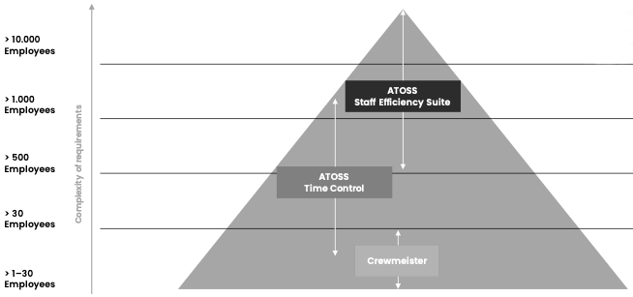

Figure 1: ATOSS Product Portfolio

One of the important in Atoss product lineup is Mobile apps. It offers mobile apps for smartphones and tablets which provide employees and managers access to the workforce management software on the go. In addition, ATOSS also offers integrations with other systems such as payroll and HR systems, which allows for seamless data exchange between systems and helps to improve data accuracy and efficiency. Furthermore, ATOSS provide consulting services to help businesses optimize their workforce management processes, and training services to ensure that employees can use the software effectively. The product lineup also has Crewmeister, a software for small businesses and agile departments without any instillation and ready to go solution. It supports time recording, shift planning and holiday planning3, refer to Figure 1.

ATOSS softwares are designed for a wide range of industries, including retail, healthcare, manufacturing, logistic & transportation, call center, and service sectors including all company size. In addition to its core workforce management software solutions, ATOSS also offers a range of complementary services such as Implementation and support services, Cloud solutions, Reporting and analytics, Workforce management consultancy, and Professional Services to help businesses optimize their HR operations4.

All of these services are designed to help organizations improve efficiency, reduce costs, and increase productivity by streamlining their workforce management operations. With a strong focus on customer service and support, ATOSS has established itself as a trusted partner for organizations looking to optimize their workforce management processes.

## Business Model

ATOSS Software AG primarily operates on a software as a service (SaaS) business model. This means that the company provides its software solutions to customers over the internet, rather than selling licenses for the software to be installed on individual computers.

Figure 2: ATOSS business model canvas

|  |  |  |  |  |
| --- | --- | --- | --- | --- |
| **Key Partners** | **Key Activities** | **Value Propositions** | **Customer Relationships** | **Customer Segments** |
| Microsoft  SAP  Oracle  Capgemini  Datev  pcs  dormakaba  datafox  Bosch  pentos  empleox  sdworx | Development of WFM  Sales & marketing  Customer service and support  Professional services | Streamlined workforce management  Increased productivity  Data security and compliance  Industry-specific solutions  Support and Services | Customer service & support  Professional services  Account management  Communication and Feedback  Retention | Retail  Healthcare  Manufacturing  Services  Public Sector  Small and medium size enterprises |
| **Key Resources** | **Channels** |
| Human resources  Intellectual property  Technology and infrastructure  Partnerships and strategic alliances  Brand & reputation | Direct sales  Online presence  Partnerships  Trade shows and events  Content marketing |
| **Cost Structure** | | | **Revenue Streams** | |
| Research and development  Customer service and support  Professional services  Operational cost  Infrastructure  Legal and regulatory compliances, insurance, and taxes | | | Software sales  Services  Upgrade and enhancements  Support and maintenance  Professional services | |

### Key Activities

ATOSS Software AG's key activities include the development of its workforce management software solutions, refer to Figure 2. The company's software development team is responsible for designing, coding, testing, and maintaining the software. ATOSS engages in sales and marketing activities to promote its software solutions and services to potential customers. This includes direct sales, online sales, partnerships and resellers, trade shows and events, digital marketing, and direct marketing. The company provides customer service and support to customers who have purchased its software solutions and services. This includes troubleshooting, technical support, and access to software updates. ATOSS provides professional services such as project management, software customization, and integration with other systems. ATOSS manages the day-to-day operations of the company, such as finance, accounting, human resources, and IT. This includes managing the company's finances, hiring and training employees, and managing the company's IT infrastructure. ATOSS engages in research and development activities to improve its software solutions and services and to identify new opportunities for growth4, for further company highlights refer to Appendix Figure 6.

### Key Partners

ATOSS Software AG's key partners include technology partners, system integrators, resellers and distributors, consultants and advisors, and strategic alliances, refer to Figure 2. The company partners with other technology companies and vendors to provide customers with the best possible solutions. These partners may include companies that provide hardware, software, and other technologies that are integrated into ATOSS's workforce management solutions. ATOSS partners with system integrators to provide customers with a comprehensive solution that meets their specific needs. These partners are responsible for the implementation and customization of the software, as well as ongoing maintenance and support. The partnership with resellers and distributors to expand its reach and market presence. These partners are responsible for selling and promoting the company's software solutions and services to their customers. Consultants and advisors to provide customers with specialized expertise and industry-specific knowledge. These partners may include industry experts, management consultants, and other professionals who can help customers to optimize their workforce management processes and improve their bottom line. ATOSS partners with other companies and organizations to collaborate on projects and initiatives, share resources, and leverage each other's strengths. These partnerships include joint ventures, research and development collaborations, and other strategic alliances4.

|  |  |  |  |  |
| --- | --- | --- | --- | --- |
|  |  |  |  |  |

In addition to the key partners mentioned above, ATOSS Software AG may also rely on other partners to support its operations, such as suppliers, business partners, referral partners, industry associations and standards bodies, and academic institutions. Some of the major partners:

### 

### Cost Structure

ATOSS invests in research and development to improve its software solutions and services, and to identify new opportunities for growth. This includes costs associated with software development, testing, and maintenance. ATOSS incurs costs associated with promoting its software solutions and services, such as advertising, trade shows and events, and digital marketing. ATOSS incurs costs associated with providing customer service and support, such as technical support, troubleshooting, and access to software updates. ATOSS incurs costs associated with providing professional services such as project management, software customization, and integration with other systems. ATOSS incurs costs associated with managing the day-to-day operations of the company, such as finance, accounting, human resources, and IT. ATOSS incurs costs associated with maintaining the company's technology and IT infrastructure, such as servers, data centers, and networking equipment. ATOSS incur other costs such as legal and regulatory compliance, insurance, and taxes4.

### Business Channels

The company uses a variety of channels to market and distribute its software solutions and services. ATOSS has a team of sales representatives who reach out to potential customers directly to promote the company's solutions and services. This channel is typically used to target larger organizations and enterprise customers. ATOSS also sells its solutions and services through its website and online marketplaces, such as the Microsoft Azure Marketplace. This channel allows customers to purchase the company's solutions and services worldwide online, which can be convenient and cost-effective. It works with a network of partners and resellers to market and distribute its solutions and services. These partners include software vendors, system integrators, and other technology providers, which help to expand the company's reach and market presence. ATOSS participates in a variety of trade shows and events to promote its solutions and services also uses a variety of digital marketing channels such as social media, email marketing, search engine optimization (SEO), and Pay-Per-Click (PPC) to promote its solutions and services4.

### Key Resources

The key assets of ATOSS Software AG include its team of knowledgeable and competent employees who are responsible for the development, sales, and support of the company's software solutions and services. This human resource comprises software developers, salespeople, customer support representatives, and other professionals essential for the company's operations. ATOSS's software solutions and services are safeguarded by intellectual property rights, including patents, trademarks, and copyrights, providing the company with a competitive edge and safeguarding its market position. The company has a well-established technology infrastructure, which includes hardware and software systems, data centers, and other IT resources, supporting the development and delivery of its software solutions and services. ATOSS has also established partnerships and strategic alliances with other companies and organizations, which aid in expanding the company's market presence and reach. Lastly, ATOSS has a strong brand and reputation in the workforce management software industry, which enhances customer attraction and retention and positively impacts the company's sales and revenue5.

### Revenue Streams

ATOSS Software AG generates revenue through various streams such as software sales, services, upgrades and enhancements, support and maintenance, and professional services. The company's customer segment includes organizations across various industries looking for solutions to optimize workforce management processes, improve efficiency, reduce costs, and increase productivity. ATOSS provides services such as implementation, customization, and ongoing maintenance to help customers get the most value from their software solutions. The company generates revenue from software sales, upgrades and enhancements, support and maintenance, and professional services. The customer segment includes organizations of all sizes5.

### Customer Segment

ATOSS Software AG's customer segment includes a wide range of organizations across various industries. The company's software solutions are designed to help businesses optimize their workforce management processes, and as such, they are applicable to organizations of all sizes and in a variety of sectors.

According to Q3, 2022 results, ATOSS offers solutions that optimize workforce management processes for various industries, including retail, healthcare, manufacturing and production, services, logistics, and more. Specifically, these solutions include time and attendance tracking, scheduling, and absence management, refer to Figure 3. Retail companies make up 22% of ATOSS' overall sales, healthcare organizations contribute 15%, manufacturing and production companies generate the highest sales at 29%, services bring in 16% of sales, logistics account for 10%, and the remaining 9% comes from other industries such as the public sector and small and medium-sized enterprises3.

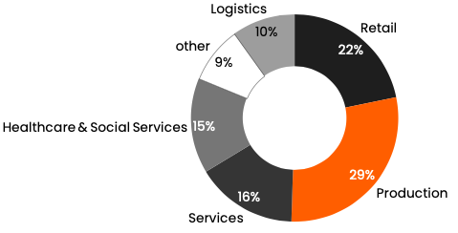

Figure 3: ATOSS Sales by Segment

### Value Propositions

ATOSS Software AG offers a range of value propositions, including streamlined workforce management, increased productivity, data security & compliance, industry-specific solutions, and support & services, to help improve its customers' business operations. These solutions help to streamline processes, increase efficiency, and ensure compliance, leading to improved productivity and bottom-line results.

### Customer Relationship

ATOSS Software AG places a strong emphasis on building and maintaining strong customer relationships. The company's customer relationship management (CRM) strategy is designed to ensure that customers are satisfied with the company's solutions and services and that their needs are met5.

**Customer service and support:** ATOSS provides a dedicated customer service and support team to assist customers with any issues or queries they may have. The company's support team is available to help customers with installation, configuration, and ongoing maintenance of the software.

**Professional services:** ATOSS also offers professional services such as project management, software customization, and integration with other systems. These services are designed to help customers optimize their use of the software and ensure that they are getting the most value out of the solutions.

**Account management:** ATOSS assigns an account manager to each customer to ensure that they are getting the support they need and that their needs are being met. The account manager is responsible for keeping in touch with the customer, understanding their needs and ensuring that they are satisfied with the solutions and services provided.

**Communication and Feedback:** ATOSS maintains a regular communication with its customers, through newsletters, surveys, or through personal visits. This helps the company to stay informed about customer needs and preferences, and to make any necessary adjustments to its solutions and services.

**Retention:** ATOSS puts a strong emphasis on customer retention, by providing ongoing support and services to its customers, keeping them informed about new features and updates to the software, and by addressing any issues or concerns they may have.

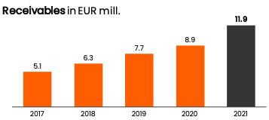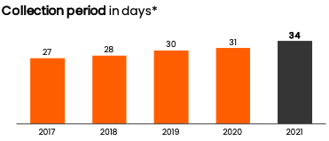

Figure 4: Benchmark, Customer Satisfaction and Stability

The small number of outstanding receivables and short duration of collecting payments are indicators of strong customer relationships and efficient business operations. The minimal need for adjustments further demonstrates the stability and trustworthiness of the company's business model3, refer to Figure 4.

Overall, ATOSS Software AG's customer relationship management strategy is designed to ensure that customers are satisfied with the company's solutions and services, and that their needs are met. The company uses a combination of customer service and support, professional services, account management, communication and feedback, and retention to build and maintain strong customer relationships. Some of the customers of ATOSS:

|  |  |  |  |
| --- | --- | --- | --- |
|  |  |  |  |

## Market Position

ATOSS Software AG is a leading provider of HR management software, which is used in 52 countries by more than 10,000 customers. In terms of market position, ATOSS is considered to be a well-established player in the workforce management software industry. The company has been in business for over 30 years and has a strong reputation for delivering high-quality software solutions and services. The company's software solutions are widely used in various industries such as retail, manufacturing, healthcare, and services. ATOSS has a diverse customer base, which includes small and medium-sized businesses, as well as large enterprises. The company's solutions are designed to be flexible and scalable, which allows customers to use the software to meet their specific needs[4].

In terms of competition, ATOSS Software AG competes with other providers of workforce management software, such as SAP, Oracle, Workday, ADP, IBM, Infor, Ceridian, UltiPro, Workforce Software and certain new but promising players. The company differentiates itself by offering a comprehensive suite of software solutions and services, as well as by providing industry-specific expertise and a strong commitment to customer service and support[5].

### Competition

**SAP**: SAP is a leading provider of enterprise software solutions, including HR management software. The company has a strong reputation and a large customer base, and its solutions are widely used in various industries. SAP's solutions are considered to be more complex and sophisticated compared to ATOSS, and they are more suitable for large enterprises[6].

**Oracle**: Oracle is another major provider of enterprise software solutions, including HR management software. The company has a strong reputation and a large customer base, and its solutions are widely used in various industries. Like SAP, Oracle's solutions are considered to be more complex and sophisticated compared to ATOSS, and they are more suitable for large enterprises[7].

**Workday**: Workday is a provider of cloud-based enterprise software solutions, including HR management software. The company has a strong reputation and a growing customer base, and its solutions are widely used in various industries. Workday's solutions are considered to be more flexible and easy to use compared to ATOSS, and they are more suitable for small and medium-sized businesses[8].

In terms of market position, ATOSS Software AG has a strong reputation and a diverse customer base, and its solutions are widely used in various industries. The company differentiates itself by offering a comprehensive suite of software solutions and services, as well as by providing industry-specific expertise and a strong commitment to customer service and support. In comparison with its competitors, ATOSS is considered to be more affordable and has a solution that is more suitable for small and medium-sized businesses.

## Financial Situation

### Results: Q1 2021 to Q3 2022

ATOSS Software AG, a company in the workforce management software industry, reported strong financial results for the third quarter of 2022. The company's group revenues increased by 18% to 81.9 million EUR in the first three quarters compared to the previous year's 69.5 million EUR[9], refer to Figure 5. Operating earnings also rose to 21.6 million EUR with an EBIT margin of 26%. The company's Cloud & Subscriptions business has become the largest share of total sales at 29%, an increase from 20% the previous year. Licenses, CSS and HW & Others contributed 25%, 7%, and 11% respectively. The Management Board is confident in their sales and earnings forecast for the 2022 fiscal year, expecting to close the year with further record figures, refer to Figure 6. The company's strong Q3 results are driven by their cloud business, which grew by 79% to 9 million EUR and recurring revenue also grew by 35% to 17 million EUR. ATOSS's software is in high demand by companies looking to maximize efficiency during an economic downturn, and the company is expected to exceed their conservative full year guidance. Since the 2022 annual report is not published now, the analysis is limited to Q3 of 2022. For balance sheet refer to Appendix Figure 4.

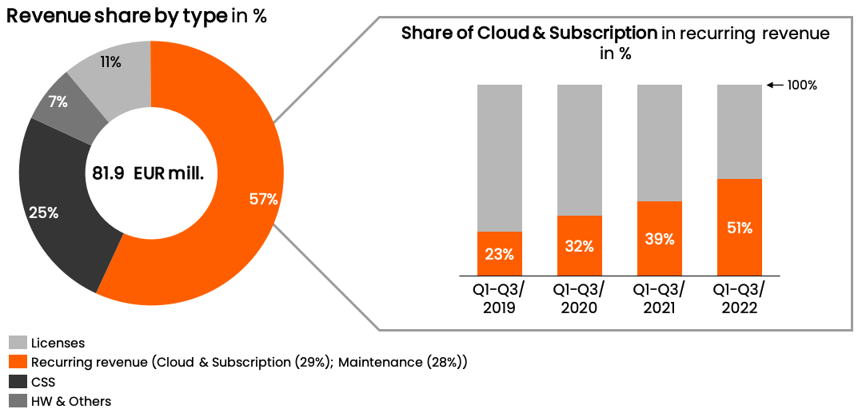

Figure 6: ATOSS Revenue share Q1-Q3 2022

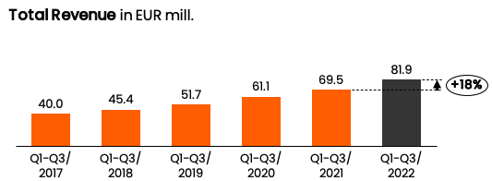

Figure 5: ATOSS top key figures Q1-Q3 2022

### Stock

In the last few years, ATOSS Software AG's stock has been volatile, with periods of growth and decline, refer to Appendix Figure 2. In 2020, the stock performed relatively well, reaching a high of €44.20 in August, an increase of over 40% from the beginning of the year, but then it fell down to €35.80 in September. This was likely due to the impact of the COVID-19 pandemic on the global economy and the stock market. However, compare to other WFM giants, ATOSS share gain 71% while other companies dropped by as low as 70%, refer to Figure 7.

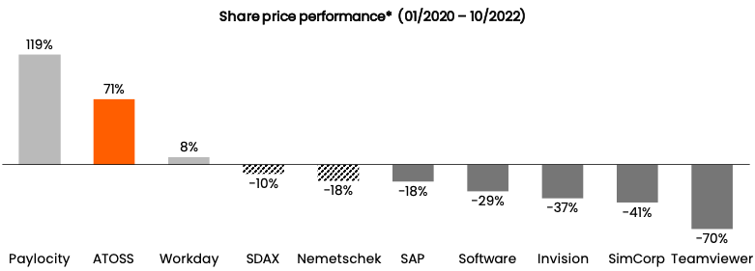

Figure 7: High Performer in European Software and HCM Stocks

In 2021, the stock performance of ATOSS Software AG was positive, with a steady growth of the stock price, reaching a high of €57.00 in June and €58.00 in July. The company's financial performance during this period also improved, with sales of €86.053 million in 2020 (previous year: €71.4 million) and an operating result (EBIT) of €26.165 million (previous year: €19.3 million). The net income for the year 2021 remained at €17.714 million (previous year: €13.5 million)10,5.

Another important factor to consider when analyzing ATOSS Software AG's stock performance is the company's dividends. ATOSS Software AG has a history of paying dividends to its shareholders, and in 2020, the company paid a dividend of €0.80 per share, which represented a dividend yield of 1.8%. The company also announced a dividend of €0.80 per share for 2021, which was paid out in October3.

In addition to dividends, ATOSS Software AG's valuation has been relatively stable in the last few years, with a price to earnings ratio (P/E ratio) of around 20-22. A P/E ratio of 20-22 is considered to be average for a company in the technology sector, indicating that the market perceives the company to have average growth potential.

## Employees

### Employer Branding and Strategy

Employer branding is the process of creating a positive image of a company as an employer, in order to attract and retain top talent. ATOSS Software AG's employer branding and strategy includes elements such as Highlighting company culture by emphasising its positive and supportive company culture in its employer branding efforts. This includes promoting its values, mission, and vision, as well as its commitment to employee development and engagement. Focusing on employee benefits, it offers to attract and retain top talent. This include things like health and wellness programs, flexible work arrangements, and retirement plans5. ATOSS promotes the career development opportunities it offers to employees, such as training, mentoring, and advancement opportunities. This can help attract and retain employees who are looking for a long-term career path. It also features employee testimonials in its employer branding efforts, as this can help to build trust and credibility with potential candidates. ATOSS uses social media and digital platforms to promote its employer brand and reach a wider audience. Company promotes the awards and recognition it has received as a great employer, such as the creative prize of the Association of Taxpayers in Bavaria e. V. (2002), the IIR Innovation Prize (2002), Europe's (2002 and 2003), Bavaria's Best 50 (2003), and Top Employer Deutschland (2023). And an employee referral program that incentivizes current employees to refer their friends and colleagues. This can help to attract high-quality candidates who are more likely to be a good fit for the company culture5.

### Employee analysis and employer rating

ATOSS operates with over 630 employees worldwide which has grown over the years from 269 in the year to 679 employees until Q3 of 2022. These 679 employees divided into Administration (98), Services (183), Sales & Marketing (152), and Innovation & Development (246). This numbers increasing each quarter since 2011, refer to Figure 8.

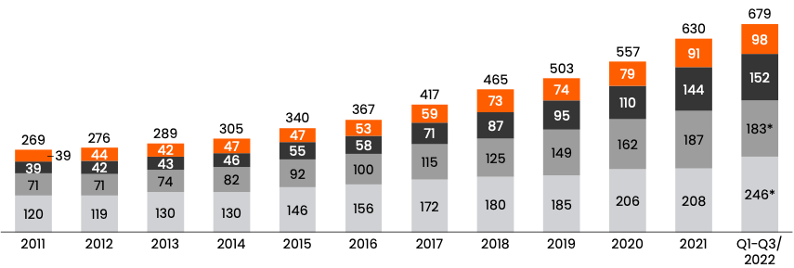

Figure 8: Continuous Expansion of Personnel Capacities

According to kununu.com, an employee rating website, Atoss Software AG's employee satisfaction is rated at an average of 3.5 points for salary and benefits, 3.8 for company image, 3.4 for career and further education opportunities, 3.5 for working atmosphere, 3.3 for communication, 4.3 for co-workers, 3.3 for work-life balance, 3.4 for superior behavior, 3.9 for interesting tasks, 3.8 for working conditions, 3.3 for environmental and social awareness, 4.0 for equal rights and dealing with older colleagues. Overall, employees have positive view towards the company but there is room for improvement in certain areas such as work-life balance, communication, and environmental/social awareness. The company's average score corresponds to the average score of IT sector[10].

## Marketing

ATOSS Software AG primarily uses the following marketing channels to reach its customers:

**Direct sales:** ATOSS has a direct sales team that works with customers to understand their needs and offer customized solutions. The direct sales team is responsible for building long-term relationships with customers and ensuring customer satisfaction5.

**Online presence:** ATOSS has a strong online presence, with a comprehensive website and social media accounts. The website provides detailed information about the company's products and services and includes a resource center where customers can access white papers, case studies, and other educational materials5.

**Partnerships:** ATOSS works with a network of partners and resellers to reach customers in different regions and markets. These partners help ATOSS to extend its reach and provide local support to customers5.

**Trade shows and events:** ATOSS regularly participates in trade shows, conferences, and events related to HR management software. These events provide a platform for ATOSS to showcase its products and services and network with potential customers5.

**Content marketing:** ATOSS also uses content marketing to reach customers. This includes creating and distributing blog posts, eBooks, webinars, and other content that is relevant to the HR management software industry5.

ATOSS Software AG uses a combination of these marketing channels to reach its customers and build its brand.

## Company Strategy

ATOSS strategy is be focused on providing comprehensive HR management software solutions that are tailored to the specific needs of different industries, with a strong commitment to customer service and support, and utilizing partnerships and collaborations to provide customers with the best possible solutions. The company's global presence and industry-specific expertise also play an important role in its strategy, as they allow the company to reach a wider audience and provide specialized solutions. Additionally, the company places a strong emphasis on continuous improvement and innovation, which helps to ensure that its software solutions remain relevant and competitive in the marketplace. The company's affordability also plays a key role in its strategy, allowing small and medium-sized businesses access to industry-specific software solutions, that are tailored to their specific needs3.

### Market Analysis

The Global Workforce Management Software Market is expected to grow with a compound annual growth rate (CAGR) of 14.29% for cloud-based solutions and 5.98% for on-premise solutions between 2020 and 2025. In 2020, the market size was valued at $3023.5 million and is projected to reach $5162.38 million by 2025. In 2020, 60% of the market was comprised of cloud-based solutions, while 40% was on-premise. By 2025, the market is expected to shift to 69% cloud-based and 31% on-premise, refer to Figure 9. The study conducted by Technavio shows that 81.17% of the growth between 2020 and 2025 will be contributed by cloud-based solutions[11].

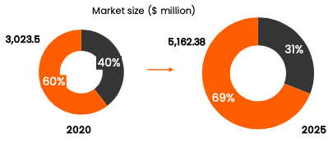

Figure 9: WFM Market Predictions

### Company Forecast

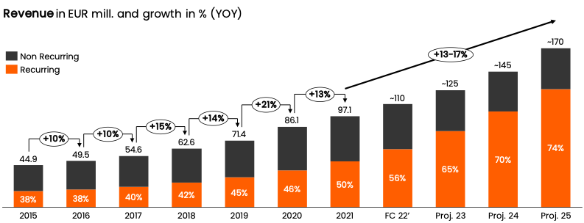

Figure 10: Revenue forecast by 2025

ATOSS projects strong growth in revenue and margins while building recurring revenue. In 2022, total revenue is expected to be greater than 110 million EUR with an EBIT margin of over 25%3. The total revenue growth for 2022 to 2025 is projected to be between 13-17% per year with an increasing share of recurring revenue from 50-75%. Software revenue growth is expected to be between 14-20% per year and EBIT margin is expected to increase from 25-30%, refer to Figure 10. The international revenue share is expected to increase from 16% to 25% by 2025. ATOSS has solutions in 50+ countries with 11 software languages. By 2025, non DACH revenue allocation is expected to be 10% with DACH being 90%, totaling 170 million3.

## Appendix

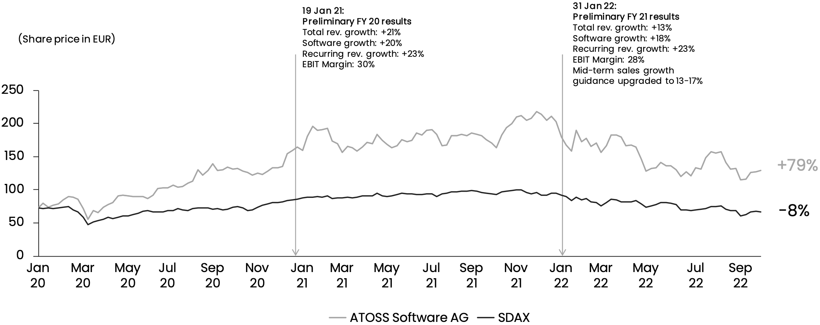

Appendix Figure 2: ATOSS stock – Jan 2020 to Sep 2022

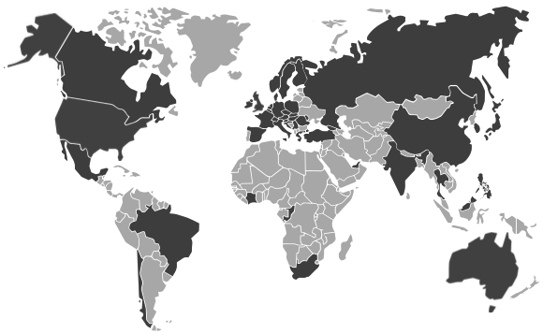

Appendix Figure 1: ATOSS global operations demographic

Appendix Figure 3: ATOSS consolidated profit and loss statement

Appendix Figure 4: ATOSS consolidated balance sheet

Appendix Figure 5: ATOSS consolidated cash flow statement

Appendix Figure 6: ATOSS key highlights

1. Retrieved 26.01.2023 (https://de.wikipedia.org/wiki/Atoss)
2. Retrieved 26.01.2023 ([www.top-employer.com](https://www.top-employers.com/en/certified-top-employers-search/?globalcompany=Atoss&page=1))
3. Annual report retrieved 26.01.2023 (<presentation-equity-forum-2022>)
4. Retrieved 27.01.2023 (https://www.g2.com/categories/workforce-management)
5. Retrieved 26.01.2023 (https://www.atoss.com/en)
6. Retrieved 26.01.2023 (https://en.wikipedia.org/wiki/SAP)
7. Retrieved 26.01.2023 (https://en.wikipedia.org/wiki/Oracle_Corporation)
8. Retrieved 26.01.2023 (https://en.wikipedia.org/wiki/Workday,_Inc.)
9. Retrieved 26.01.2023 (https://www.yumpu.com/en/document/read/8303834/atoss-hold-eur-2220-atoss-ag)
10. Retrieved 26.01.2023 (https://www.kununu.com/de/atoss-software)
11. Retrieved 28.01.2023 ([www.technavio.com](https://www.technavio.com/report/workforce-management-software-market-in-europe-industry-analysis))